**Batalog User Manual**

**1 – Using the Website**

Welcome to the Batalog! If this is your first time using the Batalog website, then you must create an account in order to upload images and perform data analysis. Otherwise, skip to the next section.

1.1 – Creating an Account

1. In the home page, hover the mouse to the top right corner of the window and click “Signup”.
2. Input your user credentials in the entry fields.

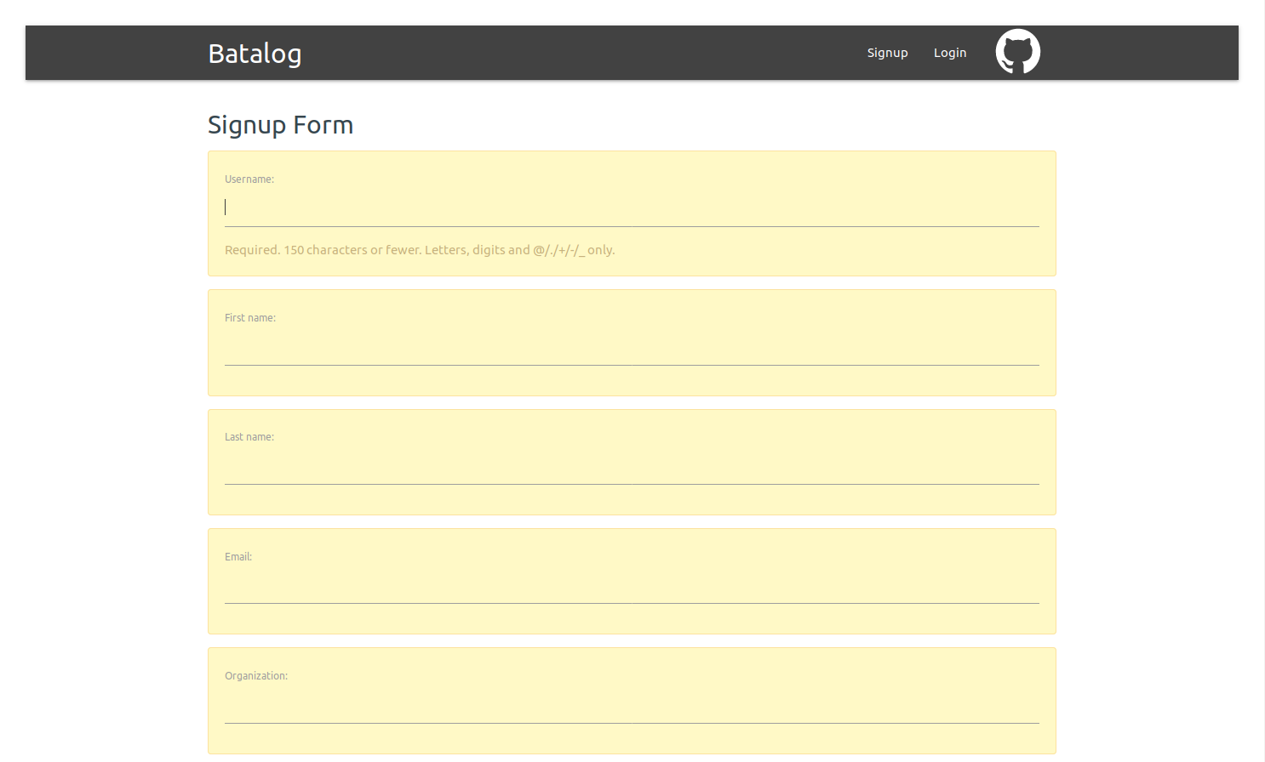

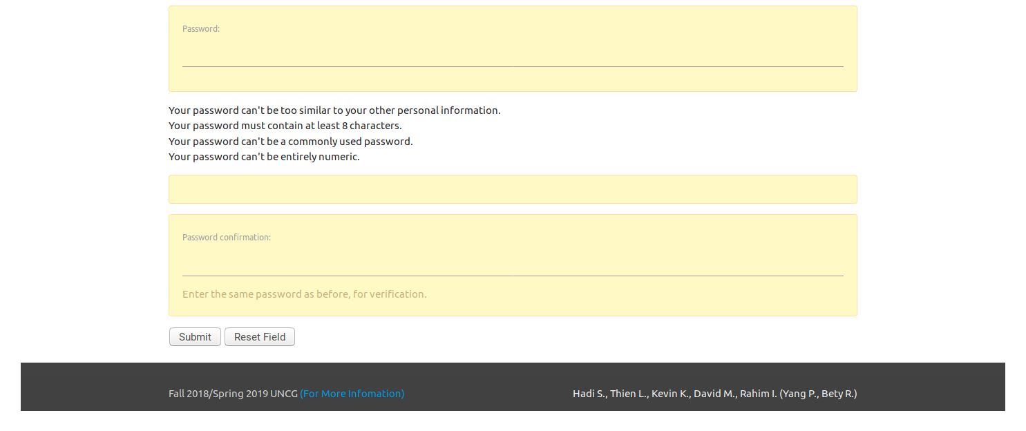

1. Click “Submit” to create your new account. You will be redirected to the home page.
   * If you are not satisfied with your input, then click “Reset Field”, which clears the fields, and start over

1.2 Log in to Your Account

Before you can perform your data analysis, you must log in to your account; this applies to newly-registered users.

1. In the home page, click “Login”. This will take you to the login page.
2. In the login page, enter the username and password that you used to create your account, and then click “Login”.

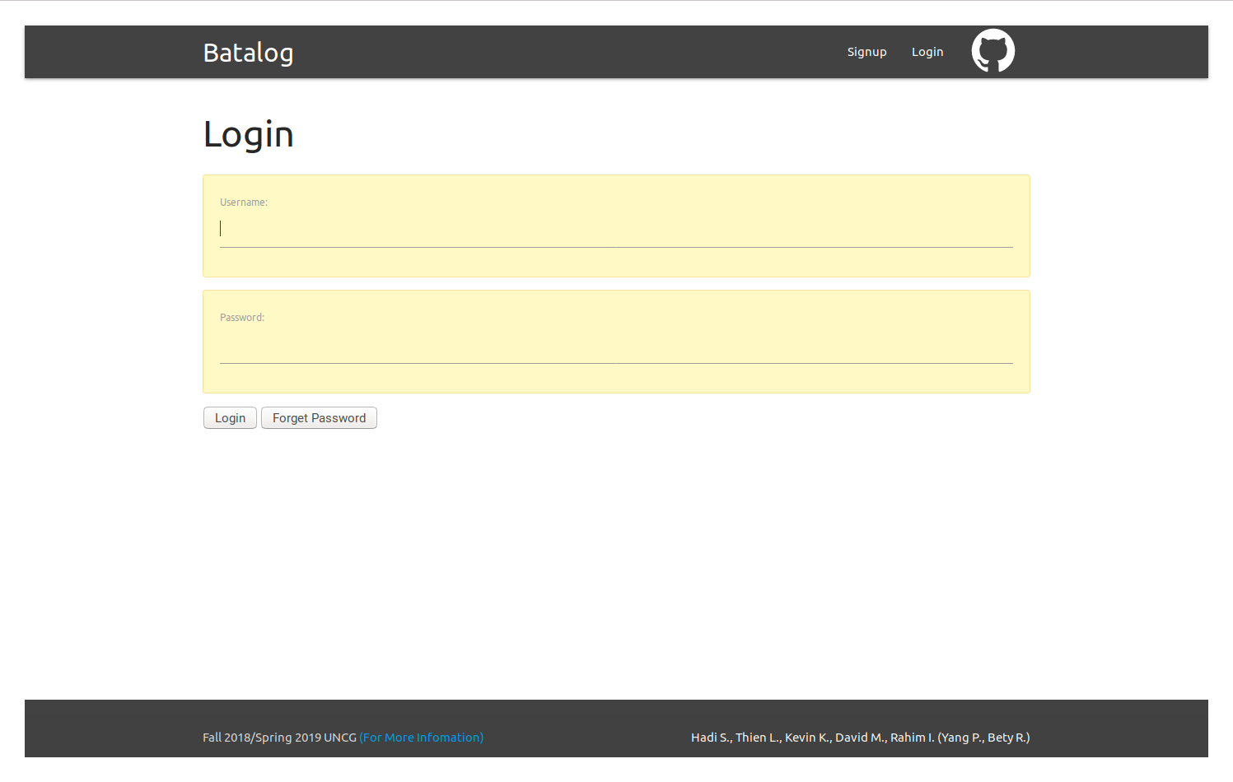

1. If your credentials match, then you are granted access to the website. This is made clear when you see the “Click here To Begin!” button on the homepage, as well as “Hi (username)!” in the top right corner, next to “Logout”.

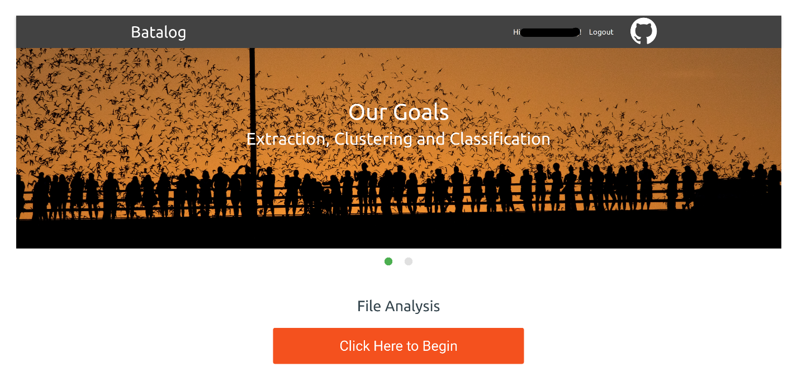

* + If you either have forgotten your password and are unable to log in, need to make changes to your current password, or want to use a new password, then click “Forget Password”, which takes you to the following webpage.

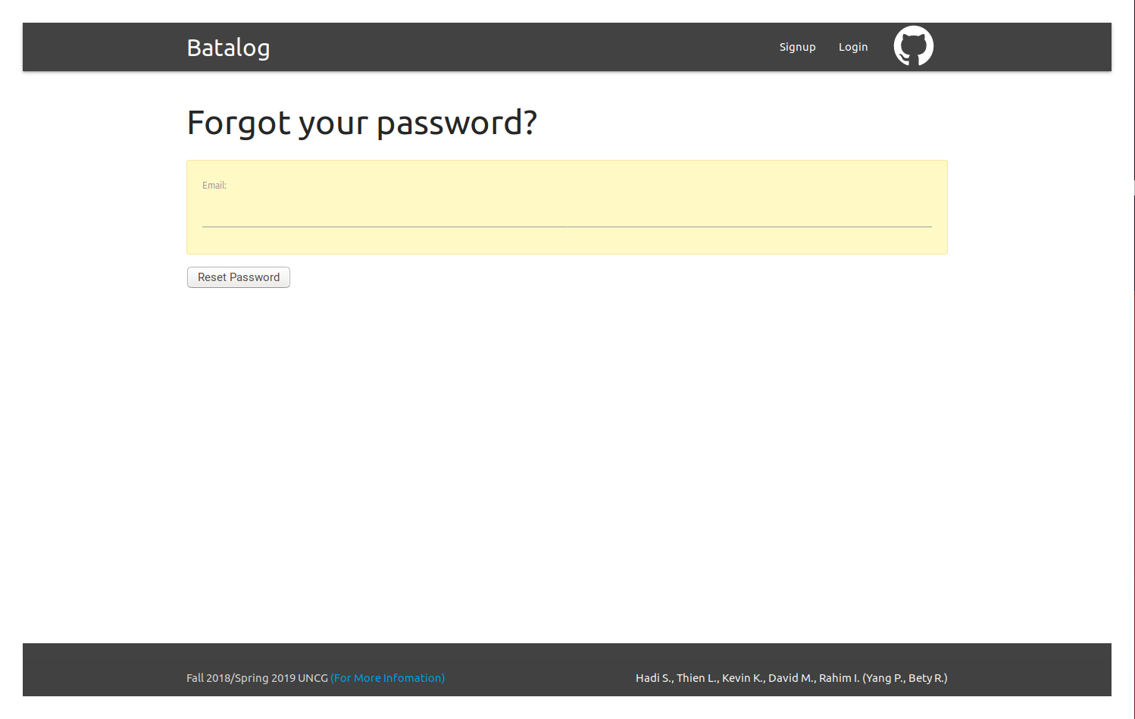

* From there, enter the email address you used to make your account and click “Reset Password”. You will be directed to another webpage containing the following information:

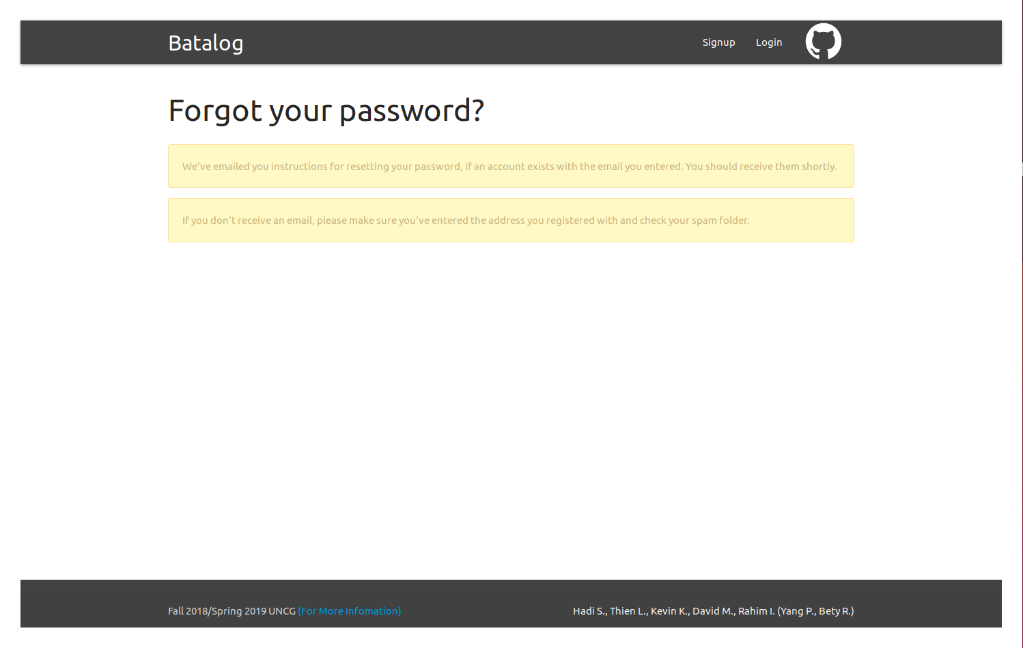

* The website will send an email with the subject line “Password reset on echobatalog” to the email address that you entered in the previous page. The email contains a link to the “Reset Password” page.

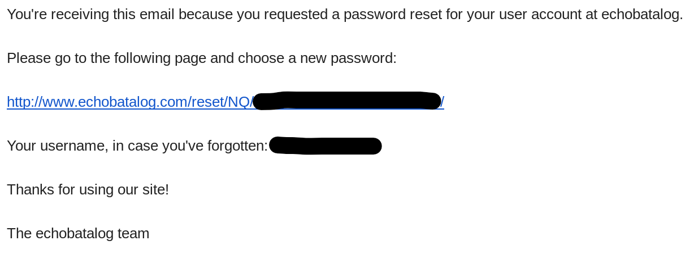

* Clicking the link will take you to the “Change password” page, where you’ll be required to enter and confirm your new password. Once you have satisfied the requirements, click “Change password”.

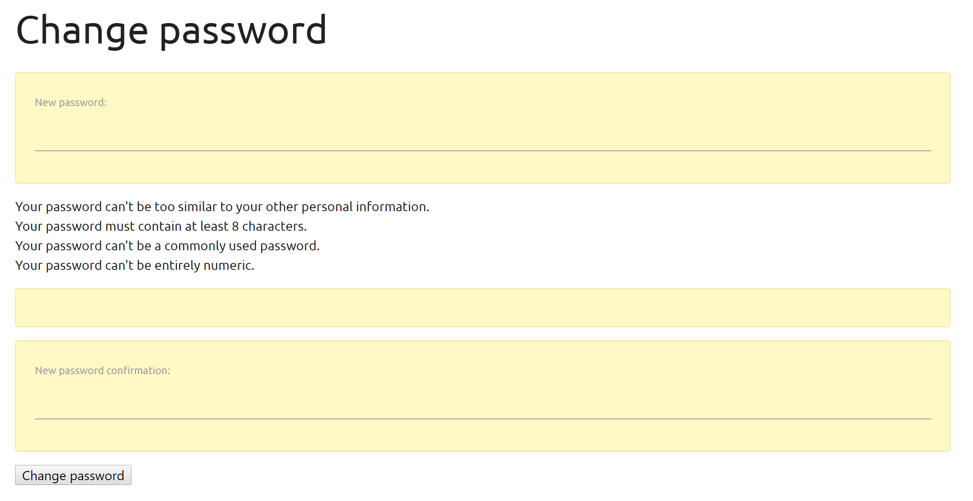

* If you use the link again after having clicked on it already, then the webpage will notify you that you will need to perform another password reset procedure.

**2 – Using the Data Analysis Modules**

Now that you’ve successfully logged in to the website, you can start using the main functional modules. To do this, you need some data to work with first before you can analyze.

2.1 – Upload Files

The system is designed to take zero-crossing files, which have an extension of two numbers followed by a pound sign (for example, “.45#”) as parsed by most computers. To begin, click the button to proceed to the upload page.

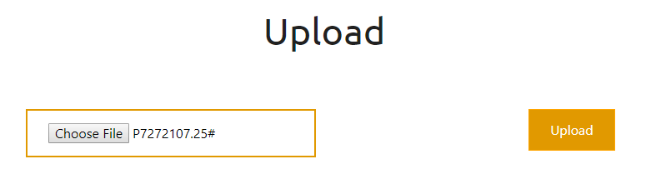

1. Upload your file or files. If you want to upload multiple files, then first place them in a compressed folder with either a .zip or .zca extension, before uploading. Click “Choose file” to select a zero-crossing file or a compressed folder file and then click “Upload”.
2. You will be treated to a loading GIF as the system processes your uploaded ZC file/s. Once the system is finished processing, you will be directed to a gallery with the images of extracted pulses, in two separate columns “Abnormal” and “Echolocation”.

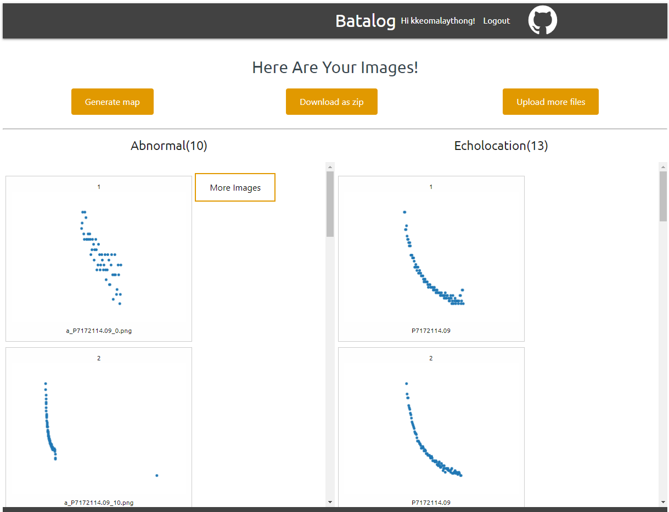

You can scroll through each column to see all the pulses that the system generated. In addition, one column may have more images than the website is able to show, so you can click “More Images” to view the rest of the pulses in that column.

2.2 – Data Analysis

Once you have your pulses, you can view the GPS locations of these bat calls in a map plot. This can be done by clicking “Generate Map”.

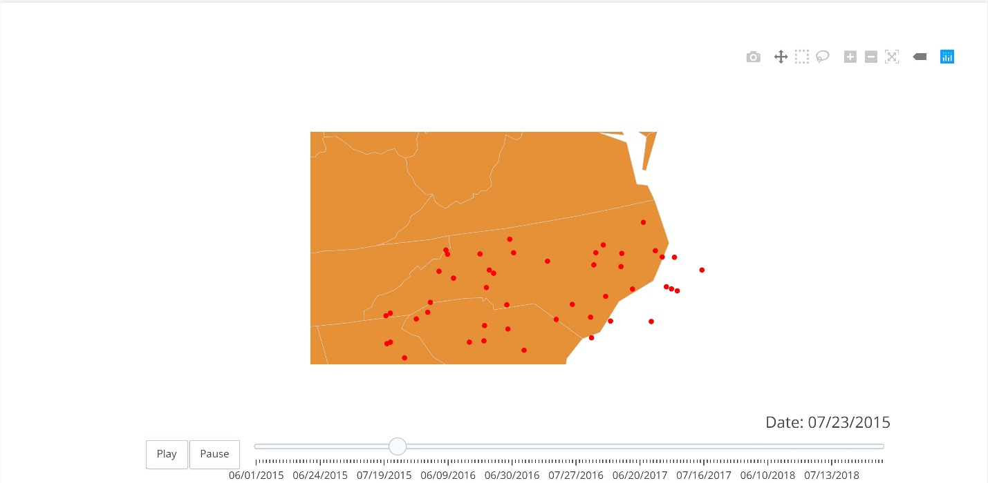

You also have the option to upload more files and obtain more results. Click “Go back” to return to the previous page and then click “Upload more files”, which takes you to the upload page - refer to Section 2.1 for upload instructions. Once you upload a new file or a compressed folder of multiple files, then you will see the resulting pulses from those files, excluding the previous pulses.

If you want to keep your results and save them to a local storage, then click “Download as zip”. The compressed folder, results.zip, will be downloaded to wherever your “downloads” directory is located on your machine. It contains two folders, “abnormal” and “echolocation”, and each folder contains the same images you see on the “Here Are Your Images!” page.



**3 – Logging Out**

Once you are finished with your data analysis, you can go ahead and log out by clicking “Logout” on the top right corner of the webpage. This will return you to the home page. The results that you received during your login session will be cleared out the moment you log out of the website. When you log back in, you will have to reupload the same files that you used in your previous login session if you want to have those same pulses again. Otherwise, you can perform a new analysis on your next login session.